North West Regional Competition Administrator
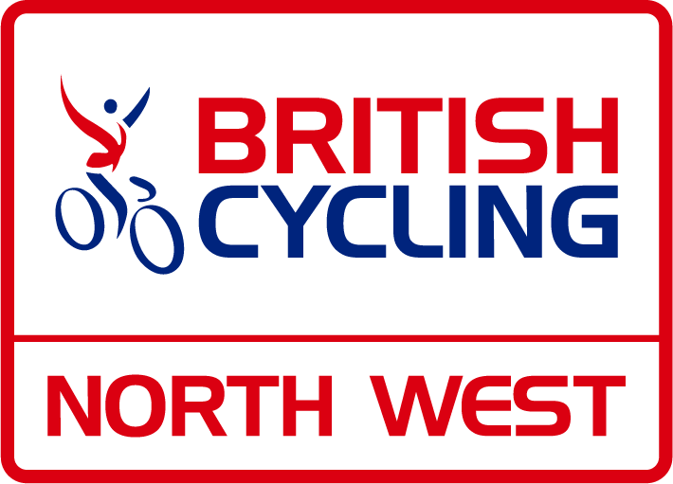
Application Form

Name |  | Region
Address
Email
Telephone
BC Membership Number if applicable

Please provide details of your experience in relation to the person specification:
Please provide details of your knowledge and skills to support your application:
I

Please provide any further details that you feel would support your application:

(Please submit to administrator@bc-nw.co.uk by 23:59 on Friday 18th November 2022)

