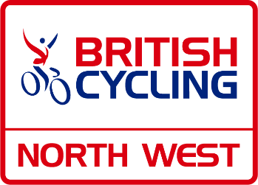
British Cycling Federation North West Region
Notice of Annual General Meeting
7.30pm, Tuesday 27th September 2022
To be held at National Cycling Centre, Manchester M11 4DQ
AGMs are a key part of our strategy to Lead our Sport, Inspire our Communities and the meeting is open to all members to attend either as a representative of your cycling club, or as a private member, should you wish to represent your club and have their voting rights, please agree this with your club/team secretary in the first instance, likewise the voting rights of Private Members will be in accordance with Byelaw 5 and a blind draw of those attending will be made to decide on those appointed to vote.
If it is your intent to attend our AGM, could you please register your interest on our website https://bc-nw.co.uk/agm-2022
The AGM meeting will follow all bye laws as detailed in the Bye Laws section of the British Cycling website HERE
All papers relating to the AGM will be placed here: - https://bc-nw.co.uk/agm-2022 10 days prior to the meeting.
The meeting will elect Officers to serve the Region for the forthcoming year and a Regional Board from nominations received all in accordance with National Byelaws and the Regions Succession plan & terms of office.
In addition, the AGM will elect five National Councillors to represent the region at National Council.
Nominations together with a CV should be received by email to the Region’s administrator administrator@bc-nw.co.uk by the 6th September 2022 .
All nominations to include membership number of the nominee, proposer & seconder. In accordance with Byelaw 6.2 all nominations and proposals can be made by an individual NW member as well as a club.

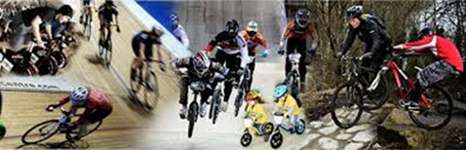
All elections will be by ballot at the AGM unless unopposed.
NW Region Board Positions for election in line with our succession planning will be for the following terms of office: -
A list of NW Board positions due election is shown below.
Treasurer to serve for 3 years
Board members x 6 - Length of service to be determined by vote counts. 3 to serve for 3 years & 3 to serve for 1 year

It is expected there to be specific responsibilities for elected board members in order that the region continues to function successfully, responsibilities to include Publicity & Media (plus website) & a second Vice Chair who will have the responsible for Welfare to support the Federations Compliance & Safeguarding Team. Please bear this in mind when submitting nominations.
National Councillors x 5 elected annually and in accordance with Byelaw 6.4.4.5

Board members will also be expected to support the workgroups and may be asked to Chair specific ones:-
The Current workgroups you can be involved in are: -
Road
Track
Off Road/MTB
Coaching & Youth
Diversity & Inclusion
Membership & Recreation
Regional Academy
Regional Delivery Plan & Finance (Board members only)
Events (Board Members only)
We welcome any members to join these workgroups and share their knowledge & passion.
If this is something of interest to you. Please contact the Regional Administrator.
Proposals are also invited for the National Council Agenda. These must be sent to the administrator@bc-nw.co.uk by 6th September 2022
Further details can be found on the NW Regional Board website; www.bc-nw.co.uk


